Question 1.

You have been asked to conduct an audit of the QA system in a client company, outline and discuss the key elements of the audit you will conduct.Explain the QA precautionary actions you may take if some aspects of the audit are not to ISO9001 standards (5 marks)

**Availability：**Will systems be available for the business at all times when required? Are systems well protected against all types of losses anddisasters?

**Confidentiality：**Will information in the system be disclosed only to those who need it?

**Integrity**：Will the information provided in the system always be accurate, reliable and timely? What ensures that no unauthorized modifications?

**Scope of an IS Audit**

• Physical and environmental review

• System Administration review

• Application software review

• Network Security review

• Business continuity review

• Data Integrity review

•An audit may vary in how much is covered. For instance, it may onlyscrutinize only 1 of these elements or a degree of all or some components described on the previous slide

* It is important to cover all elements but they do not need to be done in one assignment
* Skills sets required for each element are different

**Could depend on the client sometimes**

Question 2.

Discuss an Information Technology (IT) in business. Explain the IT, its benefits, its uses, the difference it has made to the world, and the impact. What negative impact has this had if any to the users, discuss both positives and negatives (5 marks)

Question 3.

**NZ police case study**. Discuss what went wrong in this case study (5 marks), how would you have done things differently?

* New user requirements
* Change in operating system
* from OS/2 to NT
* change in network protocol from token ring to Ethernet, TCP/IP
* Project 12 months behind, project manager resigns

Question 4.

You have been asked by your manager at work to develop a proposal for a new IT project idea. Discuss the key elements that he will require for submission to the investment committee to ensure funding is made available, i.e. what resources, technology, timing, budgets, etc. will be required (5 marks)

* Determine the SIZE of the project：software metrics: lines of code, function points
* Determine the EFFORT required：Person hours, days, weeks or months
* Decide on the RESOURCES needed e.g. how many engineers or programmers
* Calculate the DURATION e.g. 20 person-hours, 3 people:

∴ DURATION = 20 / 3 = 6.3 hours

* Calculate the COST

e.g. 20 person-hours at $70 per hour: ∴ COST = $1,400

Question 5.

You are Senior Manager of Change in the “Best IT company Pty Ltd”, you have been asked by your manager to implement a change program using the **ADKAR model**. Discuss the key aspects of this project and how you would go about it (5 marks).

Key roles:

**Employee-facing:**

* –  **Executives and senior leaders** – fulfilling the role of sponsors of change
* –  **Middle managers and supervisors** – fulfilling the role of coach for their direct reports

**Enabling:**

* **Change management resource or team** – applying a structured approach and enabling others
*  **Project team** – integrating the “people side” of change
*  **Support functions** – providing expertise
* **the five building blocks for successful change**

**A**wareness•**Of the need to change**•**Of the nature of the change**

**D**esire-**To support the change** •**To participate and engage**

**K**nowledge-On how to change-On how to implement new skills and behaviors

Ability-to implement the change To demonstrate performance

**R**einforcement- To sustain the change-To build a culture and competence around change

Question 6. You have been given a project scope for a new ERP system and are required to estimate a project costing. Describe the approach you will take, what elements of the project will you need to cost the project, and possible resources required (5 marks)

**Algorithmic cost models**

Basic effort model: EFFORT = a x (SIZE) **b**

* **Size** metric used is Lines of Code (KDSI = Thousands (Kilo) Delivered Source Instructions)
* **a**= 1.05, 1.12, or 1.2, depending on development mode (simple, intermediate or complex)
* **b**varies between 1.01 and 1.26 depending on certain other characteristics
* These **parameters** are empirical values based on a database containing cost data for more than 60 different projects

**What is an ‘empirical’ model**

* A model is based only on data which can be used to predict, but not explain the behaviour of a system.
* An empirical model consists of a mathematical function that can mimic the trend seen in the observed data
* There is no underlying theory to help explain the behaviour

Question 7. You are a senior IT Project Manager at IBM and are working on a project for Telstra. Describe the possible risks and what you will do to ensure the project is on track and all risks are mitigated,describe what measures you would take to ensure timely delivery of the project. (5 marks)

* Time overrun on particular task, e.g. INCIS, Opera house
* Staff illness
* Staff leaving
* Technical ‘hitch’ – need for invention
* Technology failure
* Late delivery
* Failure to meet specifications
* Budget overrun

**Mitigating Risk**

Reduce the likelihood an adverse event will occur

Reducing impact of adverse event.

Examples:

* Ensure good staff conditions
* Employ multiple employees who can cover for each other
* Build some slack into the project schedule
* Have several projects on the go concurrently
* Have disaster recovery plan in place

Question 8. As an IT professional you may be interested in joining the Australian Computer Society, outline the benefits of joining the ACS, what factors will influence you joining this organisation (5 marks)

* be honest, forthright and impartial
* loyally serve the community
* strive to increase the competence and prestige of the profession
* use special knowledge and skill for the advancement of human welfare.

**Benefits**

* Brings an added competitive edge and professional readiness
* International Recognition Global acknowledgement of CP as the benchmark for professionalism
* Strengthening of employment and marketability
* Greater job mobility

Question 9. As an IT project engineer, ethics in your professional is of utmost importance. However, you know that in your company, many of the IT engineers are incorrectly using unauthorised software from a large supplier, would you ignore it this malpractice, or what steps would you and should take? (5 marks)

Question 10. You are running a very successful IT software company. One day you receive a call from a client for help on a new project. What decision support process will you use, what methods and information will you call on to help you both understand and then provide this client with a quote to win the contract ? (5 marks)

**Steps in problem solving**

1. Define problem

2. Gather intelligence

This involves collecting information about the system

It may involve constructing a model of the system, which could be concrete or mathematical

3. Consider possible solutions to the problem and evaluate them

4. Choose preferred solution (can depend on objectives)

5. Implement the solution

6. Monitor success or otherwise of chosen solution

**Satisficing**

A ‘good enough’ solution

* Decision maker is satisfied with a reasonable level of performance as opposed to the “best” possible
* May be sub-optimal but can be arrived at much more quickly
* Simon’s idea of ‘bounded rationality’

Question 11. As the Senior IT project Manager you are required to provide the key performance measures and an update to your executive team and client before they provide further project funding. Explain what KPI’s you will focus on to ensure client sign of for the next phase of the project. (5 marks)

* cost or schedule performance index (CPI or SPI)
* customer satisfaction,
* employee satisfaction,
* value of new business,
* net profit before tax,
* return on investment,
* comparison of this period with last period
* net cash flow,
* expenses as a ratio to revenue,
* health and safety record,
* manufacturing capacity and operational efficiency

Question 12. You are asked by your manager to source a new Business Intelligence software package, outline the key elements that you would look for when sourcing this new package for your company? (5 marks)

1. data warehouse containing both internal and external data

2. businessanalytic tools for manipulating, mining, and analyzing data

3. a set of business performance indicators for monitoring and analyzing performance

4. user interface

Question 13. You have been asked by your manager to conduct a Business Intelligence exercise for the new CRM system to be implemented. Describe what you would do to ensure your management has adequate information to make a decision. (5 marks)

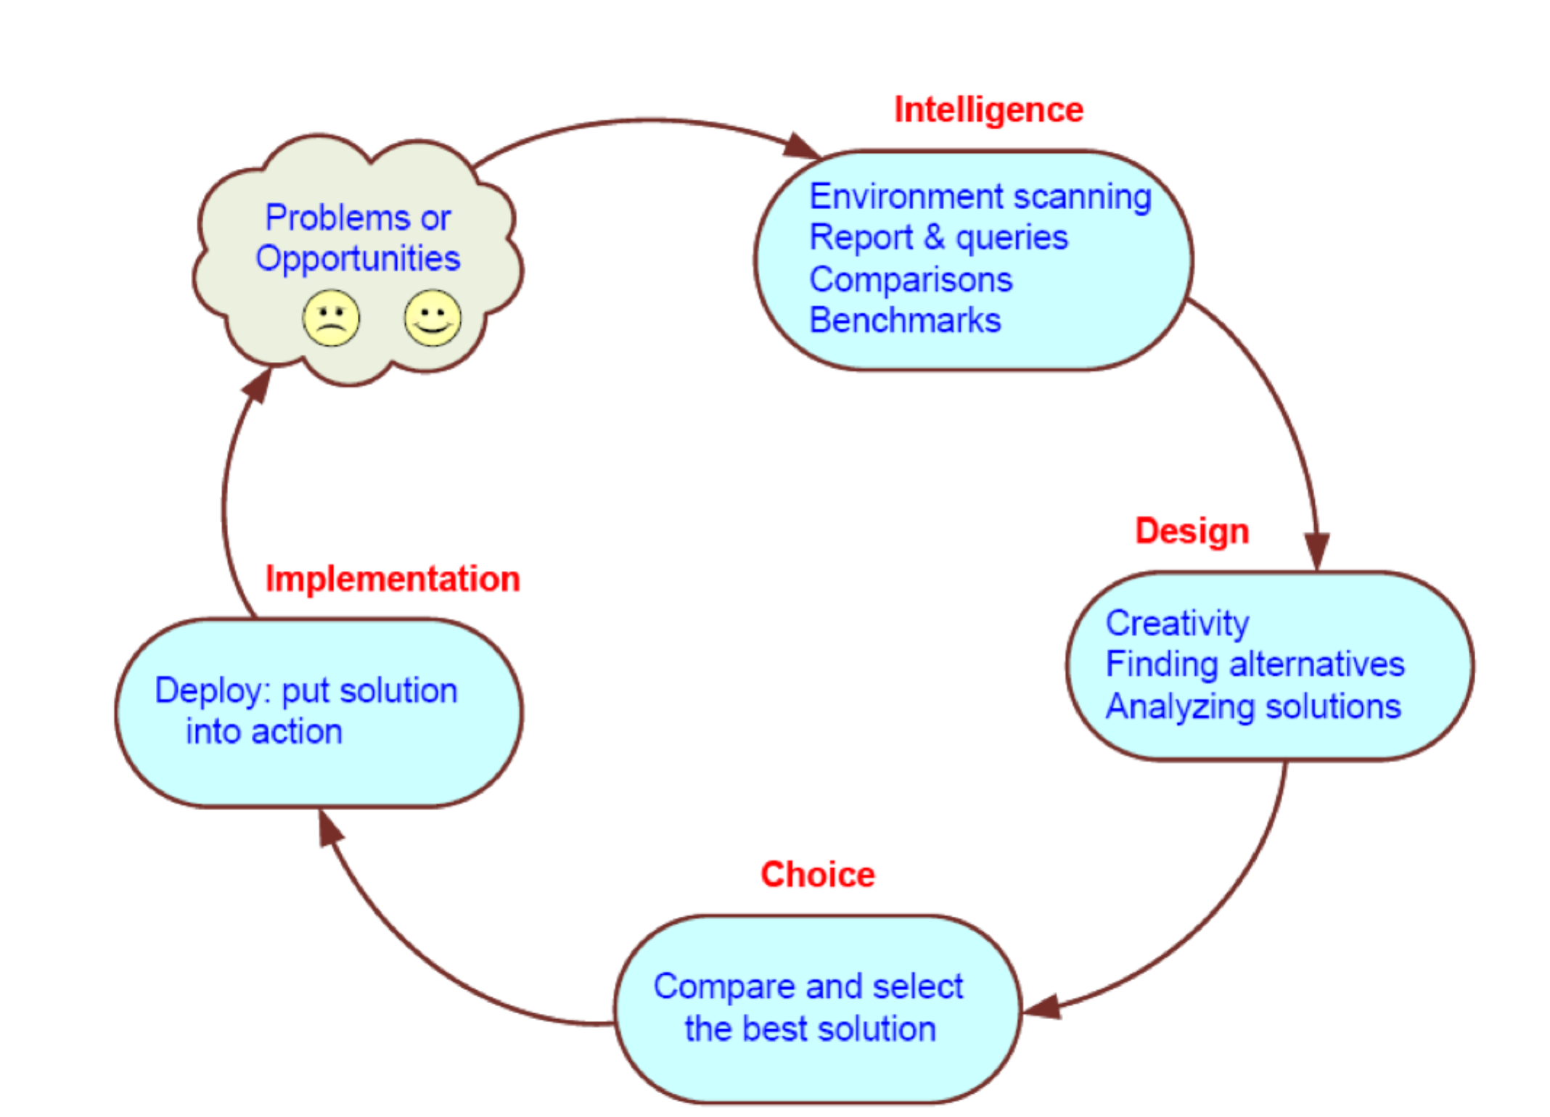

Question 14.

You are the project manager for the Mobile banking app. With “Your new Bank”. The project is failing with major risks of technology not working, and expected time to complete slipping. Describe the project to your senior executives, and explain your contingency plans need to be executed. (5 marks)

Question 15.

You are the test manager for a large banking integration project. Describe the process of testing you would incorporate, explain your strategy. (5 marks)

**Component Test**

* To ensure that each component behaves ‘correctly’.
* Uses white-box testing to check each program function fully.

**Integration Test**

• To test interaction between related components.

• Focuses on interfaces between components.

**System Test**

• To ensure that the user requirements have been met.

• Focuses on usual business processes, and normal workflow.

**Performance Test**

* To test system performance under maximum expected load.
* Simulates key processes under maximum load.

**Soak Test and Stress Test**

• To ensure that system is stable over extended period.

• Load increased until system fails. Checks effects of over-load

**Acceptance Test**

• Compares system functionality against agreed-on user requirements

• Carried out by client using scenarios, supervised by developer

**The test plan**

* Total budget for testing, £1 million
* Testing to be carried out off line (so as not to interfere with live system)
* Capacity model: to simulate user load two years into future
* Usage model: typical mix of tasks  Test database: full-sized database, sincesize affects performance
* To include soak and stress testing

Question 16. You are facing a critical path in your IT implementation as outline below, particularly task number 8 is in jeopardy of being delayed. Describe what options you have to bring the project back onto schedule. (5 marks)

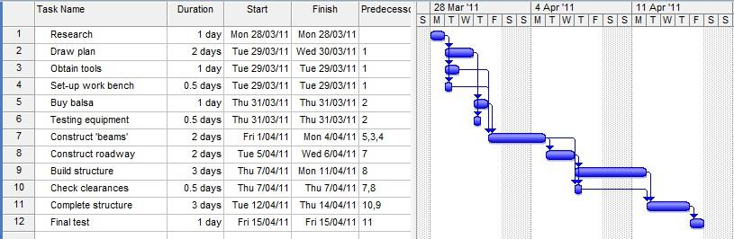

Paper code: XXXX Semester 2, 2013 Page 4 of 4

Question 17.

Your manager has fallen sick and you are required to make a presentation to the Chief Information Officer and his senior management team on the progress of the new CRM system. You have 10 minutes to give them an update. What are the key elements of your talk? (5 marks)

1. The Message

* Be sure of the message you want to communicate
*  Decide what information, question or problem you want to present
*  **First formulate your conclusion**  Yes, this gives you an aiming point!
*  Collect supporting evidence or data  Find suitable references  Images and ‘Clip art’ can enhance
*  Word documents and Excel spreadsheets can be imported into PowerPoint

2. Structure

* Construct your presentation systematically
* Formulate your **conclusion with impact**
* Determine a strong opening
* Prepare slides containing the **main points** of the message
* Add supporting material  data visuals, graphs  quotations

3. Timing

* Work out your timing :Allow time to present key points and Leave time for conclusion
* Practise with a stopwatch
* Running overtime is unacceptable  

It is very bad form

It can affect others, e.g. at conference or meeting

It can disorientate the rest of the function

* **"Be sincere; be brief; be seated."**

4. Physical factors

* Is your audience comfortable?

Ensure that lighting is OK

Check that ventilation is OK

* Don’t obstruct their view
* Don’t stand with the light in your eyes
* If there is a microphone use it properly

Check volume

Not too close

Avoid feedback

5. Personal factors

Know your audience

*  How many in the group?
* Are they experts in your field?
* Are there non-experts as well?
* What are their interests and educational level?
* Why are they here? • What are they hoping to get out of it?

Know yourself

* Believe in what you are saying
* Be confident

 55% communication comes from facial  expressions

 38% comes from vocal quality

 7% comes from the meaning of the words   

* Talk to your audience  

Look them in the eye

Look at each individual in turn

* Speak up, speak clearly, not too fast

Things to avoid

* Don’t read your talk   Use brief notes if necessary
* Don’t turn around to read your slides  (except for in lecture !)
* Don’t walk about or jangle keys
* Avoid ‘um’, and ‘ah’ – prefer silence
* Curb irritating habits  “You know”, “sort of”, “like”, “right?”, “OK”

1. Visuals - Powerpoint

Question 18.

You are working for IBM and have been appointed to head the merger of Westpac and St. George bank’s internet banking platform. What systems integration techniques would you use, and why. You may wish to use the V model for testing. (5 marks)

